**Recent Trend In Power Generation**

Rahamath uzma

[rahamathrock208@gmail.com](mailto:rahamathrock208@gmail.com)

III B.TECH, EEE, SVITS, MBNR.

Adina areej

[adina.areej@gmail.com](mailto:adina.areej@gmail.com)

III B.TECH, EEE, SVITS, MBNR.

...................................................................

**Abstract**: Nowadays, power generation subsystems must often be packaged using limited space and strict weight limits on either ground mobile or airborne plat forms.Recent trends are to be implemented in power generation in order to increase the level and efficiency of power generation as well as to reduce losses in generation and transmission.In future many industries and military systems will heavily depend on high electrical power input ranging from 100 kw upto the multi MW level.

**I. Introduction**

The innovative parts of this paper is to represent the necessity of power for the future in various ways such as, ocean thermal energy conversion (OTEC), magneto hydro-Dynamic (MHD) power generation.

**II. METHODS OF GENERATING POWER**

Several fundamental methods exists to convert other forms of energy into electrical energy such as,

**1. OCEAN THERMAL ENERGY CONVERSION**

Ocean thermal energy conversion (OTEC) is a method for generating electricity which uses the temperature difference that exists between deep and shallow waters.Temperature difference between warm surface water and cold deep water must be >200C(360C) for OTEC system to produce significant power.Ocean Thermal Energy Conversion produce electricity from the natural thermal gradient of the ocean,using the heat stored in warm surface water to create steam to drive a turbine ,while pumping cold,deep water to the surface to re –condense the steam .OTEC is the only viable in the tropical seas,in areas where the thermal gradient between the surface and a depth of 1000m is at least 220C.

**OPERATION OF OTEC**

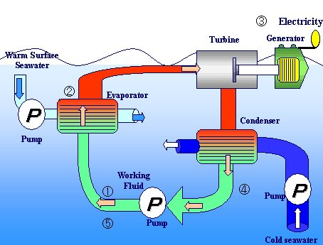

Warm seawater and cold seawater are pumped to the evaporator and condenser.The cold working fluid is pumped to the evaporator.The evaporator uses the warm sea water to vaporise the working fluid.The vapour rotates the turbine there by generating electricity.The vapour then enters the condenser where the cold sea water cools it to a fluid.The fluid returns to the pump and the cycle is repeated

**OTEC-CLOSED CYCLE**

In closed –cycle OTEC, warm seawater heats a working fluid, such as Ammonia ,which flows through a heat exchange (evaporator).The ammonia vapour expands at moderate pressure turning a turbine ,which drives a generator which produces energy .

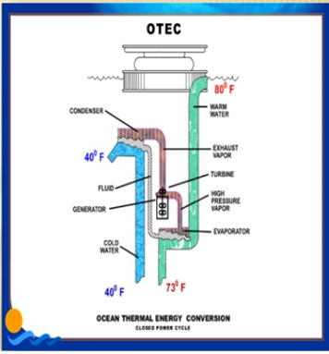

**ECONOMICAL BENEFITS**

**ADVANTAGES**

* Helps produce fuels such as hydrogen ,ammonia, and methanol.
* Produces base load electricity energy.
* Produce desalinated water for industrial, agricultural, and residential uses.
* Provides air- conditioning for buildings.
* Provides moderate temperature refrigeration.
* Potential to provide clean ,cost effective electricity for the future.

**DRAWBACKS**

* Still in the development /experimental stage.

**2. MAGNETO HYDRO DYNAMIC POWER GENERATON (MHD)**

In world 80% of total electricity produced in the world is hydral, while remaining 20% is produced from nuclear, thermal, solar, geothermal energy and from Magneto Hydro Dynamic (MHD) generation.

MHD power generation is a new system of electric power generation which is said to be of high efficiency and low pollution.

An MHD generator is a device for converting heat energy of a fuel directly into electrical energy without conventional electric generator.

**PRINCIPLES OF MHD POWER GENERATION**

When an electric conductor moves across a magnetic field, a voltage is induced in it which produces an electric current.This is the principle of the conventional generator where the conductors consist of copper strips.In MHD generator, the solid conductors are replaced by gaseous conductors, an ionized gas.if such a gas is passed at a high velocity through a powerful magnetic field, a current is generated and can be extracted by placing electrode in suitable position in the stream.The electro magnetic induction principle is not limited to solid conductors. The movement of a conducting fluid through a magnetic field can also generate electric energy.When a fluid is used for the energy conversion technique, it is called MAGNETO HYDRO DYNAMIC (MHD), energy conversion.The flow direction is right angles to the magnetic fields direction. An electromotive force (or electric voltage ) is induced in the direction at right angles to both flow and field directions.

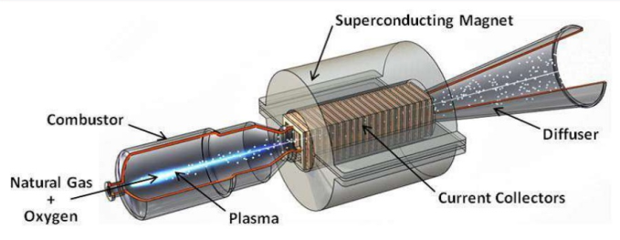

CONCLUSION
These New techniques and several methods of
power generation are to be implemented to improve
the power effici...

**Advantages:**

* The conversion efficiency of a MHD system can be around 50% much higher compared to the most efficient steam plants. Still higher efficiencies are expected in future, around 60-65% with the improvements in experience and technology.
* Large amount of power is generated.
* It has no moving parts, so more reliable.
* The size if the plant is considerably smaller than conventional fossil fuel plants.

**Drawbacks:**

The MHD system needs very large magnets and this is a major expense.

There will be high friction losses and heat transfer losses. The friction loss may be as high as 12% input.

**III. Conclusion:**

These New techniques and several methods of power generation are to be implemented to improve the power efficiency.The need of the hour is to evolve sustainable growth pattern in generation as well as transmission so as to have economical, efficient and eco-friendly power. Finally I conclude that by using advanced technologies will help the human being to survive from the present crisis of power shortage.

**IV.REFERENCES:**

* “Pearl Street Station –Engineering and Technology History Wiki” . Retrieved 2016-08-14.
* “EIA-Electricity Data” Retrieved 2016-08-14.
* “Coal and Electricity” World Coal Association, retrieved2016-08-14.
* CIA World Fact book 2009 Retrieved 2011-5-8.
* “Early Day Motion 2061” UK Parliament. Retrieved 15 may 2015.